**ER Diagram**

Entity Relationship (ER) diagram is a graphical representation of entities and their relationships to each other. It is a type of flowchart that illustrates how “entities” such as people, objects or concepts relate to each other within a system. It displays the relationship of entity sets stored in a database. In other words, ER diagrams help to explain the logical structure of databases. It is created based on three basic concepts: entities, attributes and relationships. It contains different symbols that use rectangles to represent entities, ovals to define attributes and diamond shapes to represent relationships.

**Practical Question:**

UPS (Unitied Parcel Services) prides itself on having up-to-date information on the processing and current location of each shipped item. To do this, UPS relies on a company-wide information system. Shipped items are the heart of the UPS product tracking information system. Shipped items can be characterized by item number (unique), weight, dimensions, insurance amount, destination, and final delivery date. Shipped items are received into the UPS system at a single retail center. Retail centers are characterized by their type, uniqueID, and address. Shipped items make their way to their destination via one or more standard UPS transportation events (i.e., flights, truck deliveries). These transportation events are characterized by a unique scheduleNumber, a type (e.g, flight, truck), and a deliveryRoute.

Please create an Entity Relationship diagram that captures this information about the UPS

system. Be certain to indicate identifiers and cardinality constraints.

**Solution:**

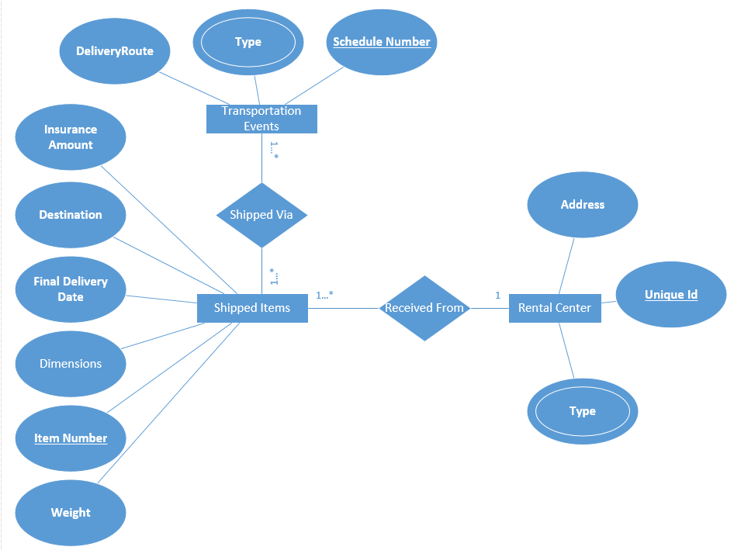

**Use Case Diagram:**

A use case diagram is a way to summarize details of a system and the users within that system. It is generally shown as a graphic depiction of interactions among different elements in a system. Use case diagrams will specify the events in a system and how those events flow, however, use case diagram does not describe how those events are implemented. A use case is a methodology used in system analysis to identify, clarify, and organize system requirements. Use case diagrams are employed in UML (Unified Modeling Language), a standard notation for the modeling of real-world objects and systems

Use case diagram uses

* Represent the goals of systems and users.
* Specify the context a system should be viewed in.
* Specify system requirements.
* Provide a model for the flow of events when it comes to user interactions.
* Provide an outside view of a system.
* Show’s external and internal influences on a system.

**Use Case diagram of Esewa:**

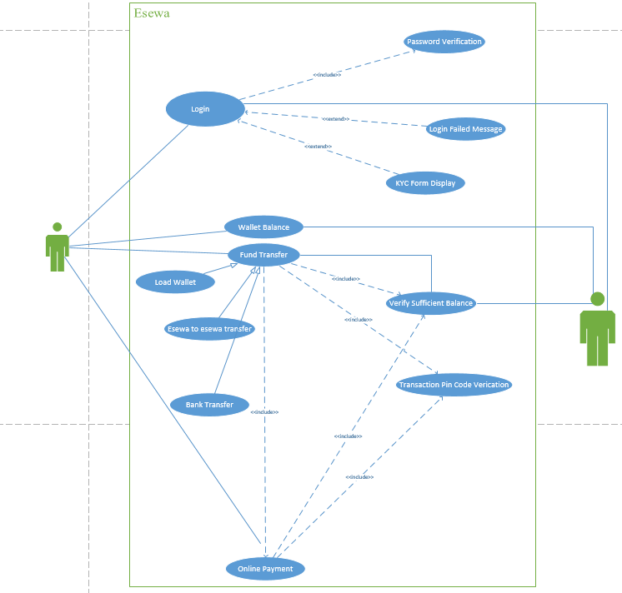

**Library Management System:**

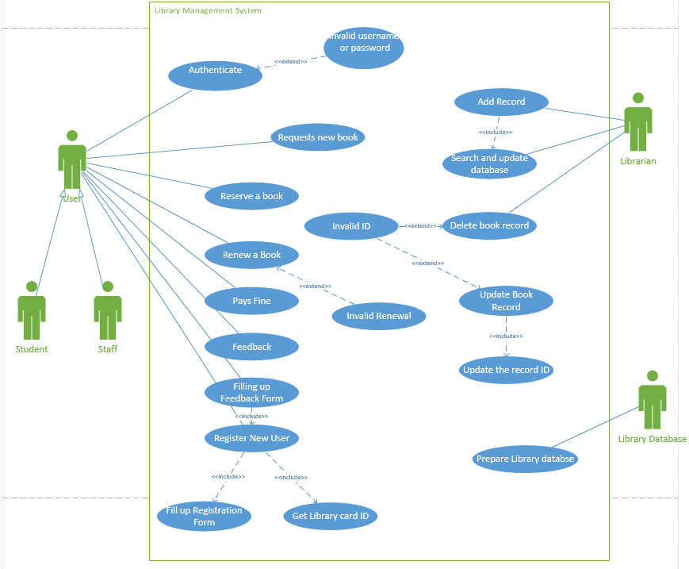

**Class Diagarm:**

**School Management System:**

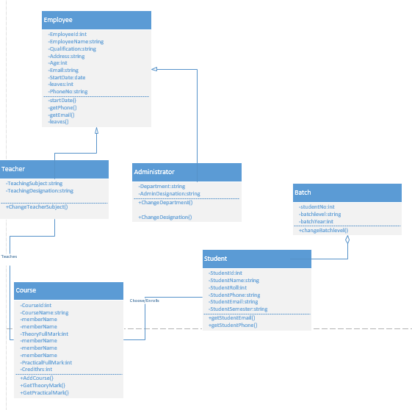

**Delivery System:**

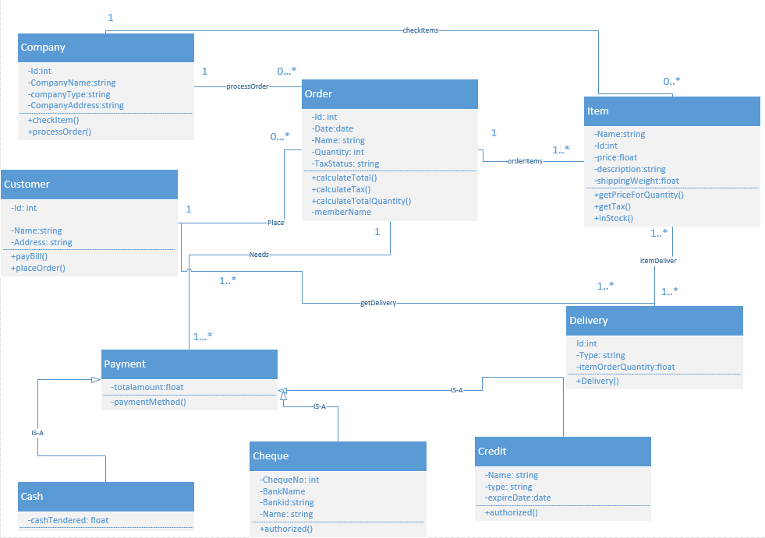

**Data Flow Diagarm:**

**Level 0 diagram of Tiktok:**

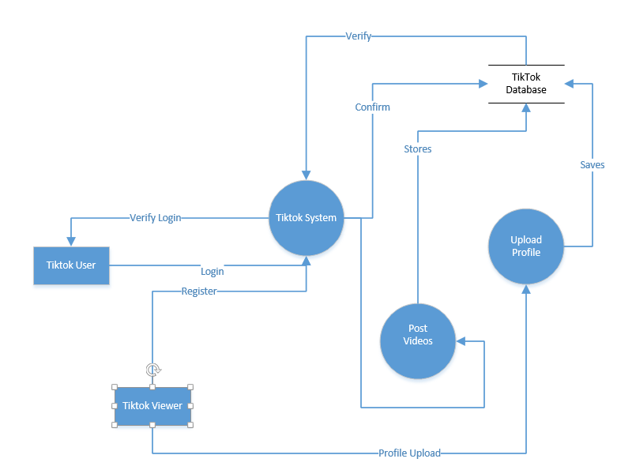

**Level 1 diagram of Tiktok:**

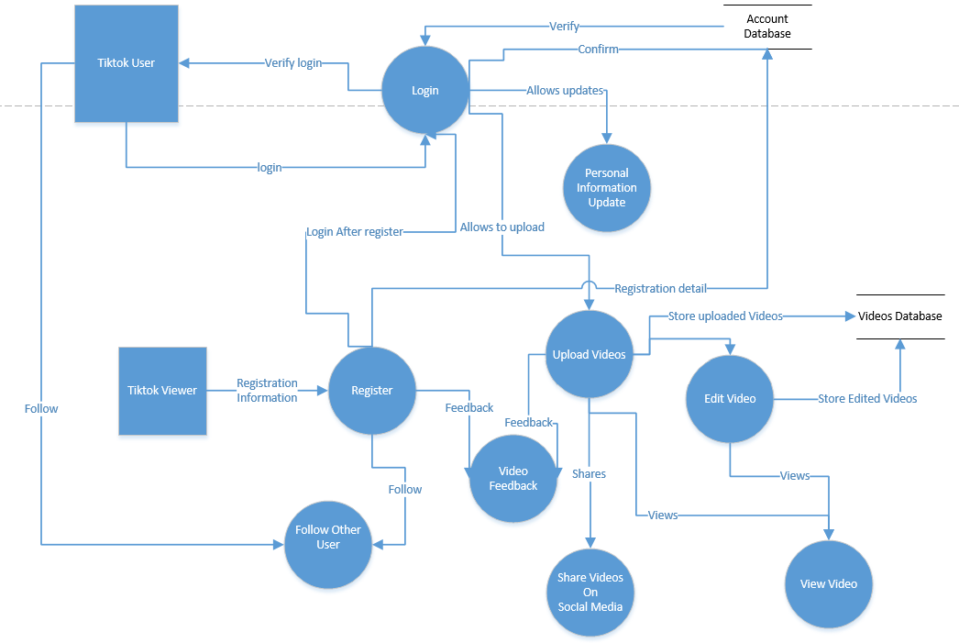

**Level 2 diagram of Tiktok:**

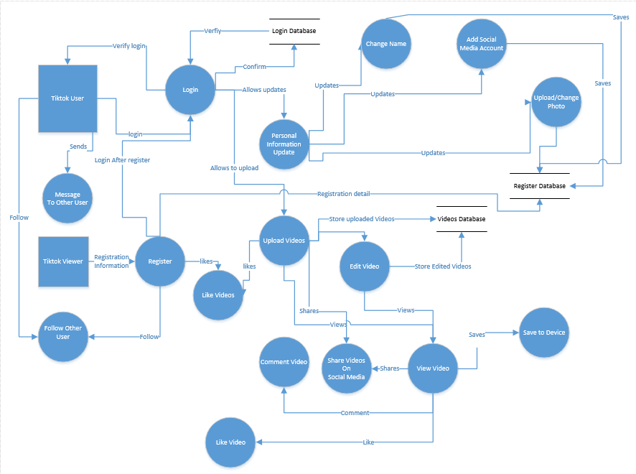

**Level 0 diagram of Youtube:**

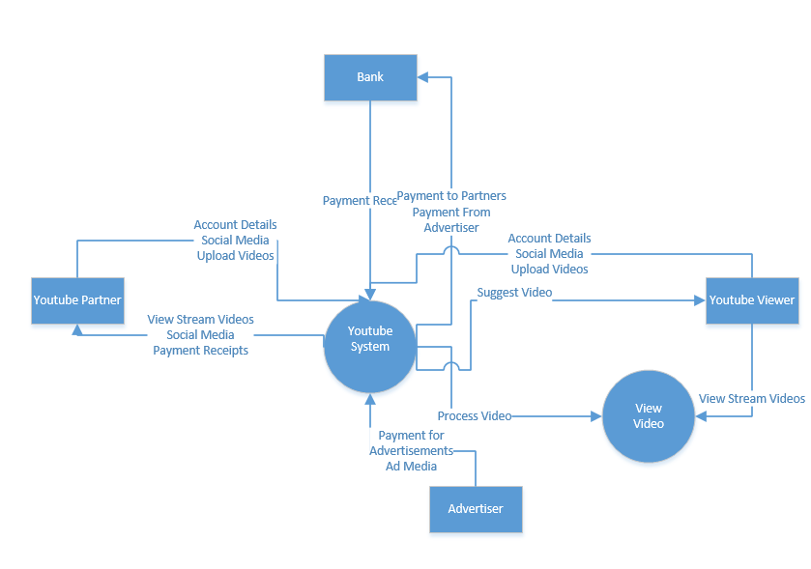

**Level 1 diagarm of Youtube:**

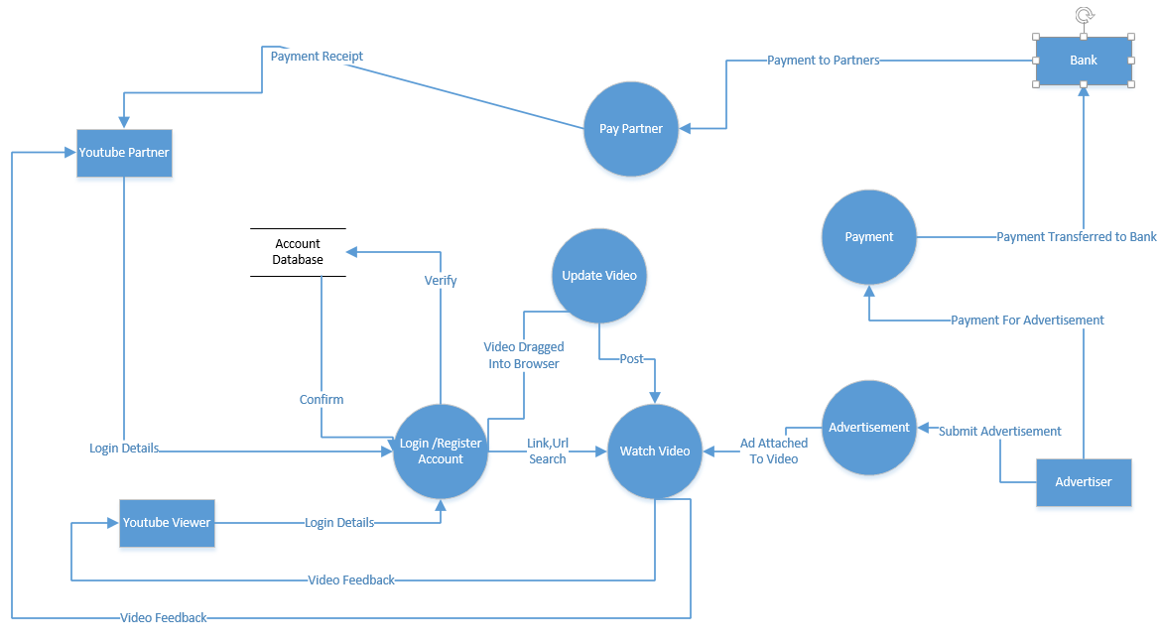

**Level 2 diagram of Youtube:**

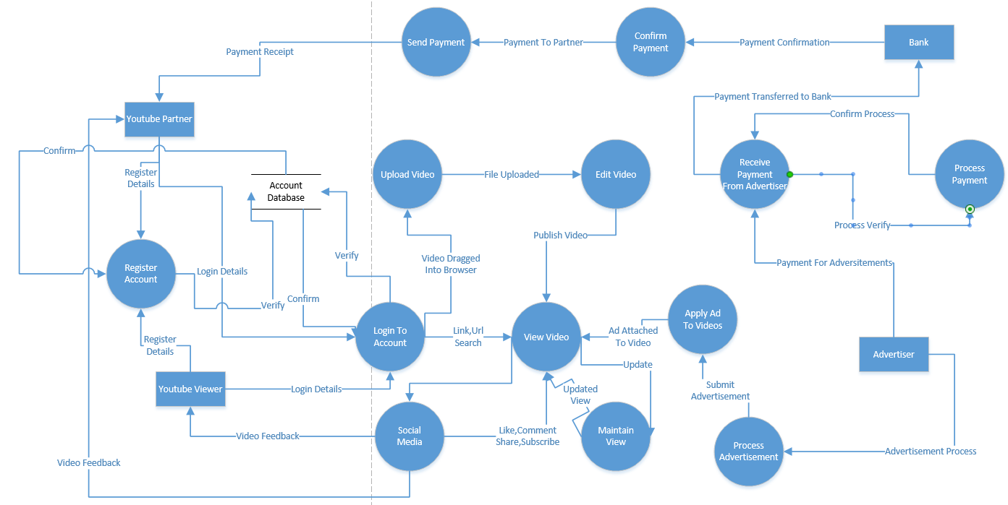

**Break Even Point Analysis**

Assuming monetary benefits of an information system at $85,000 per year, one-time costs of $75,000, recurring costs of $35,000 per year, a discount rate of 12 percent, and a five-year time horizon, calculate the net present value of these costs and benefits of an information system. Also calculate the overall return on investment of the project and then present a break-even analysis. At what point does breakeven occur?

**Solution:**

Given:

Benefits per year(Y) = $85,000

One time cost = $75,000

Recurring costs per year= $35,000

Discount rate (i)= 12 %

For present value, PVn=Y x $\left[\frac{1}{{(1+i)}^{n}}\right]$

For benefit;

In 0 year, PV0= 0 x =0

In 1st year, PV1 = $85,000 x =

In 2nd year, PV2 = $85,000 x =

In 3rd year, PV3 = $85,000 x =

In 4th year, PV4 = $85,000 x =

In 5th year, PV5 = $85,000 x =

NPV of Benefit= PV0+PV1+PV2+ PV3+PV4+ PV5 =

For Recurring Cost;

In 0 year, PV0= $35,000 x =

In 1st year, PV1 = $35,000 x =

In 2nd year, PV2 = $35,000 x =

In 3rd year, PV3 = $35,000 x =

In 4th year, PV4 = $35,000 x =

In 5th year, PV5 = $35,000 x $\left[\frac{1}{{(1+.10)}^{5}}\right]$ =

Over all cost= NPV of Recurring Cost = Onetime cost+PV0+PV1+PV2+ PV3+PV4+ PV5 =

Over all NPV = NPV of Benefit – NPV of Recurring Cost = …….. - ………

Over all ROI = Over All NPV / Over All Costs = …../….

**Break Even Analysis:**

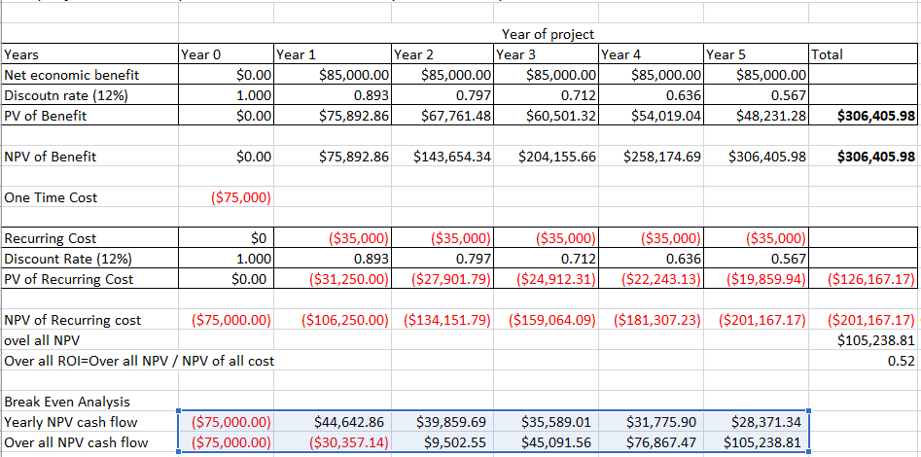

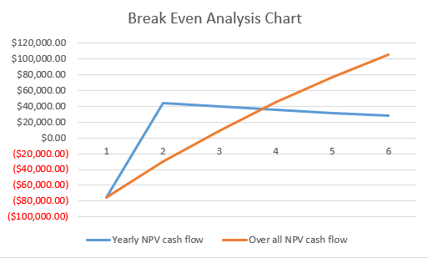

**Pert Chart:**

PERT (Program Evaluation and Review Technique) chart is a project management tool used to schedule, organize, and coordinate tasks within a project. It is a method to analyze the tasks involved in completing a given project, especially the time needed to complete each task and to identify the minimum time needed to complete the total project.

**1.Draw the PERT chart according to the following table which shows the tasks, dependencies, and estimated times for a software development project.**

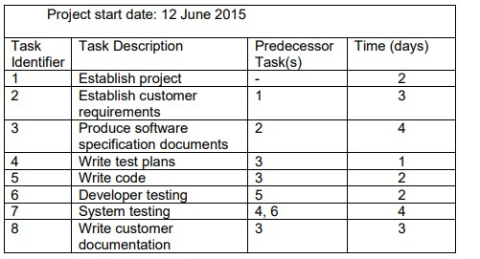

**2.Construct a network for a project whose activities and their predecessor relationship are given in table below.**

|  |  |  |  |  |  |  |  |  |  |  |  |
| --- | --- | --- | --- | --- | --- | --- | --- | --- | --- | --- | --- |
| Activity | A | B | C | D | E | F | G | H | I | J | K |
| Predecessor | - | - | - | A | B | B | C | D | E | H, I | F, G |
| Time taken  (hr) | 3 | 2 | 4 | 1 | 3 | 4 | 2 | 7 | 2 | 5 | 2 |

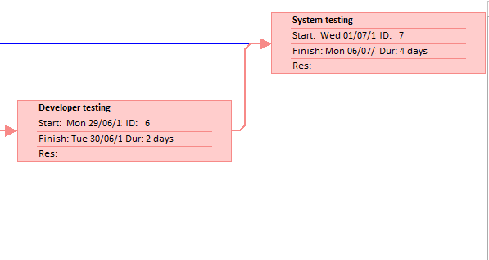**1.Solution**

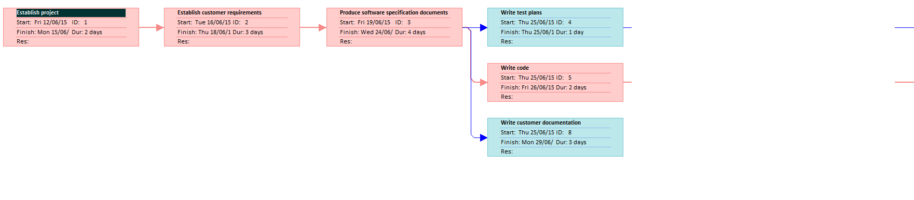

**2.Solution**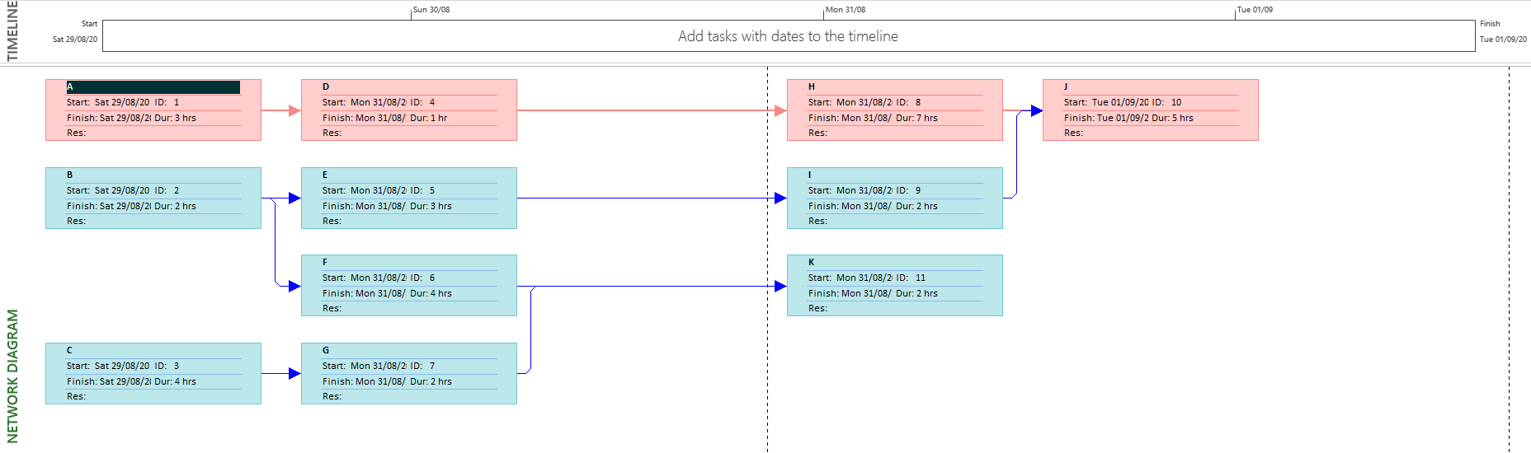

**Gantt Chart**

A Gantt chart is a type of horizontal bar chart commonly used in project management, which is a visual view of tasks scheduled overtime. It provides a graphical visualization of a schedule that helps to plan, coordinate, and track specific tasks (or elements) in a project. Gantt chart boils down multiple tasks and timelines into a single page. Using a Gantt chart allows all stakeholders to perceive the same schedule information, sets mutually understood expectations, and conducts their efforts according to the desired protocol. The Gantt chart tool provides a visual timeline for the start and end of tasks, making it clear how tasks are interrelated and perhaps rely on the completion of another before one can start.

**a.Solution**

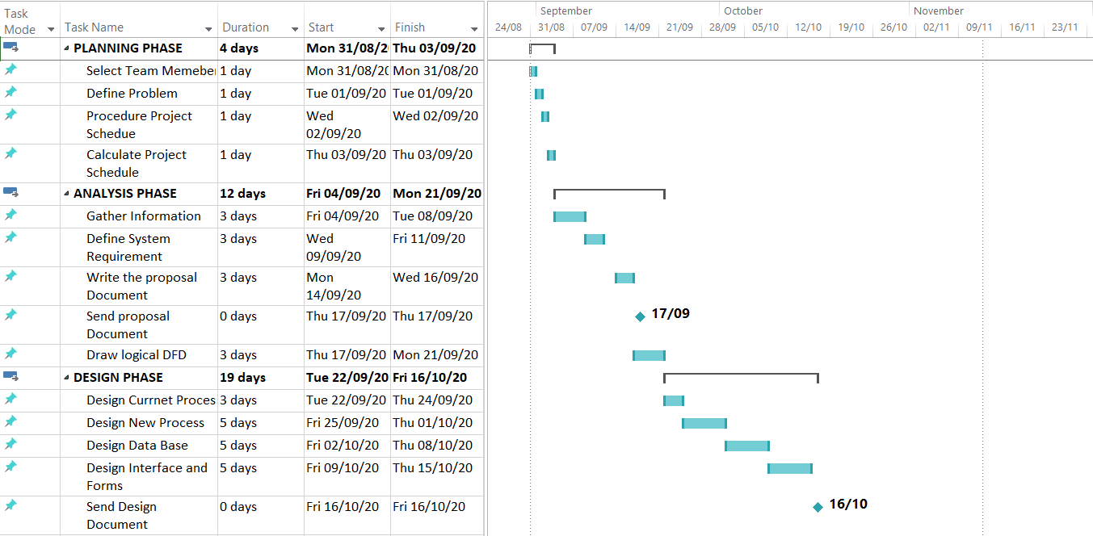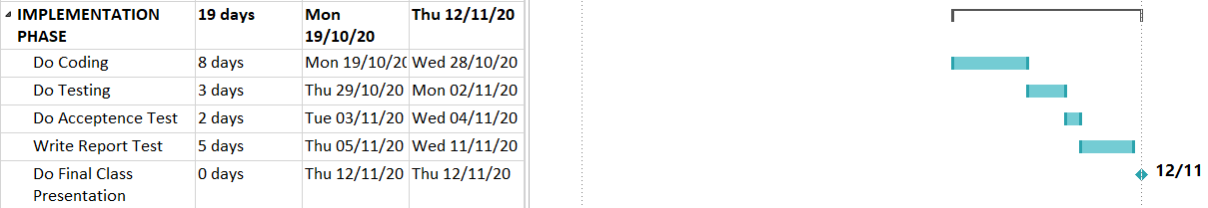

**b.Solution**

